**Basic Linux Commands**

1. How to make a directory?

We can make a directory using the “mkdir” command.

OUTPUT:

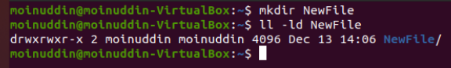

2. How to remove a directory?

We can use the “rmdir” or “rm” command to remove any directory.

OUTPUT:

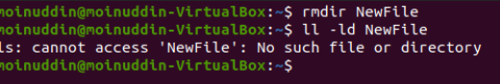

3. Make a copy of a file.

We can use the “cp” command to copy any file.

OUTPUT:

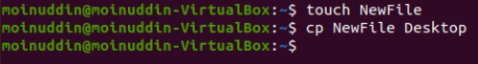

4. Move or Rename a file.

We can use “mv” command for rename or move any file in any

directory. If we use mv after any name then it just change name of

file and if provide proper destination of directory after mv

command then it will move.

OUTPUT:

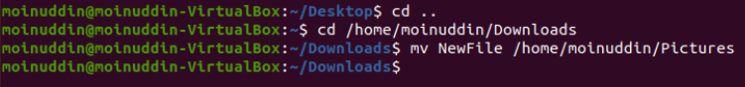

5. How to create an empty file?

We can use the “touch” command to create an empty file.

OUTPUT:

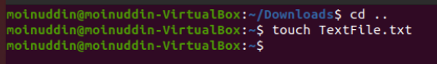

6. Remove multiple files with a single command?

We can use “rm” command to remove single or multiple files

If we use “ rm -f” here -f is a flag to force rm command to remove

Files.

OUTPUT:

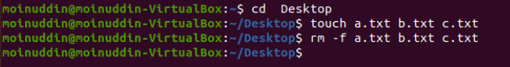

7. Remove content from the folder without removing the folder.

We can use “rm -r file_name “ to remove content from the folder

OUTPUT:

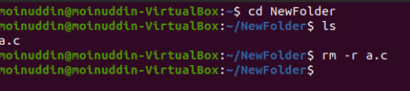.

8. Create multiple folders(a-z) in a single command.

We can use mkdir command and write folders name separated

with space.

OUTPUT:

